Hand Gesture Recognition
In this project using CNN we are recognizing hand gesture movement and to train CNN we are using following images shown in below screen shots
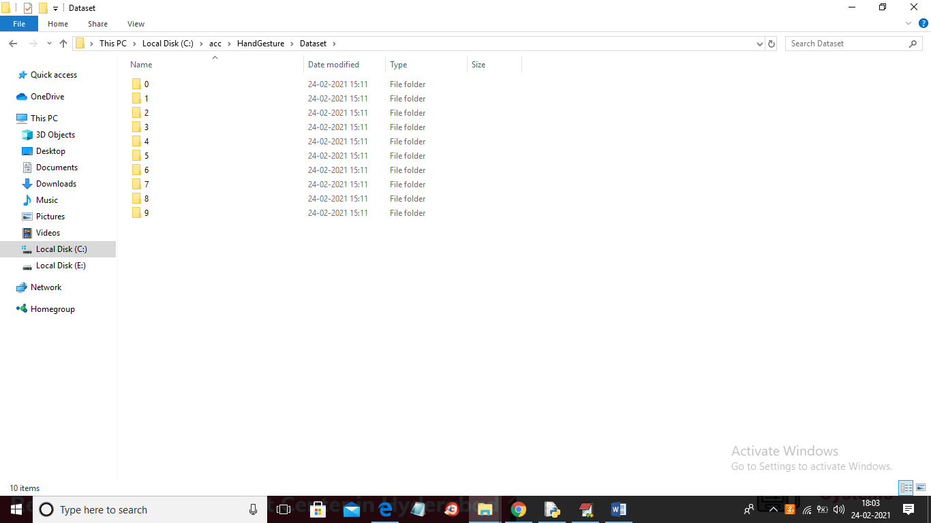
In above screen we can see we have 10 different types of hand gesture images and to see those images just go inside any folder
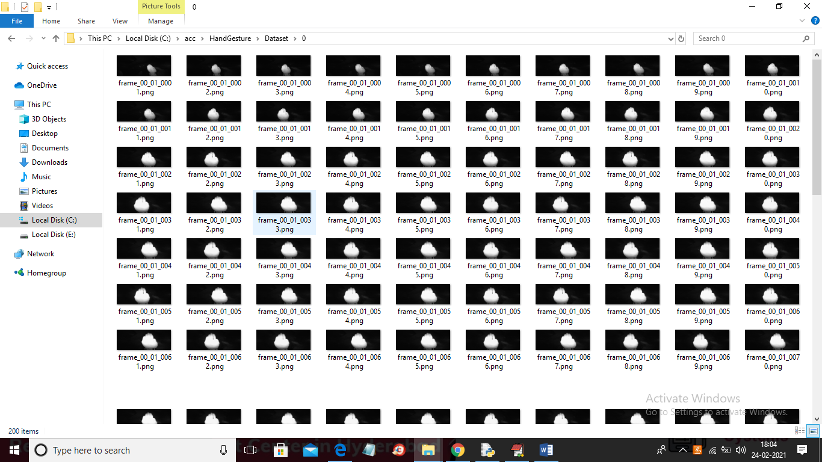
In above screen showing images from 0 folder and similarly you can see different images in different folders.
SCREEN SHOTS
To run project double click on run.bat file to get below screen
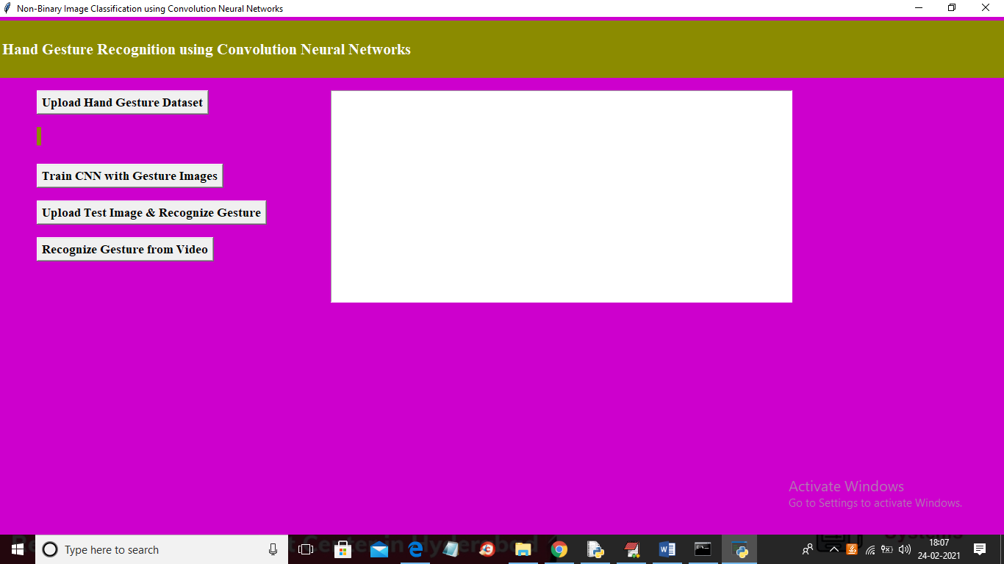
In above screen click on ‘Upload Hand Gesture Dataset’ button to upload dataset and to get below screen
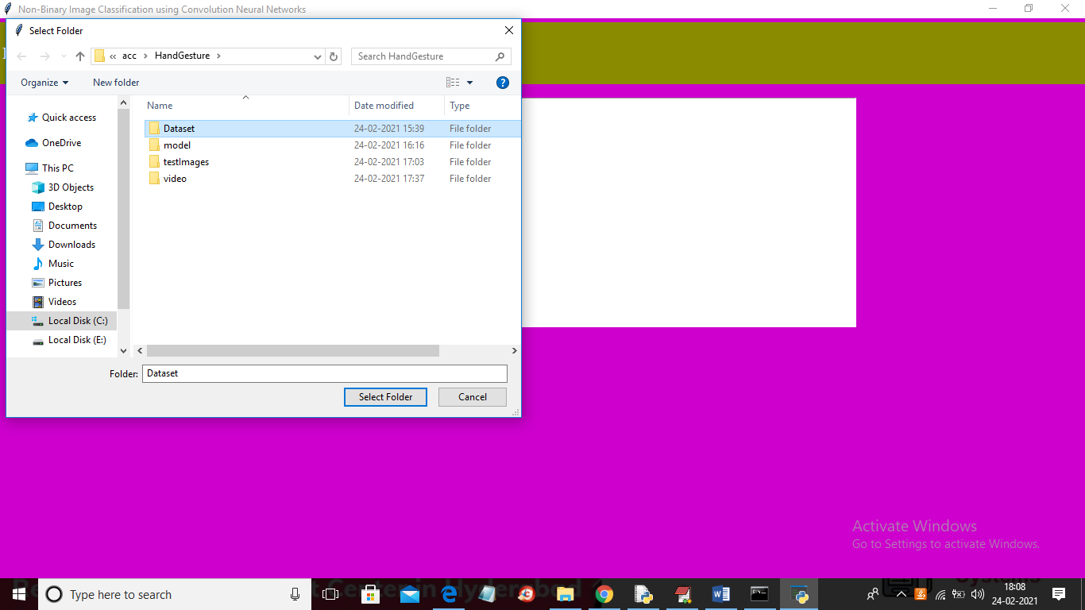
In above screen selecting and uploading ‘Dataset’ folder and then click on ‘Select Folder’ button to load dataset and to get below screen
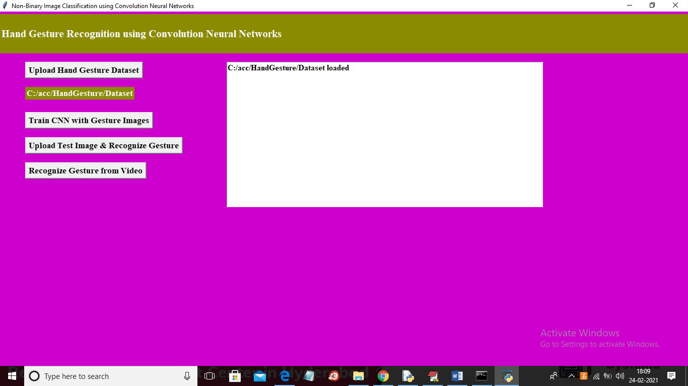
In above screen dataset loaded and now click on ‘Train CNN with Gesture Images’ button to trained CNN model and to get below screen
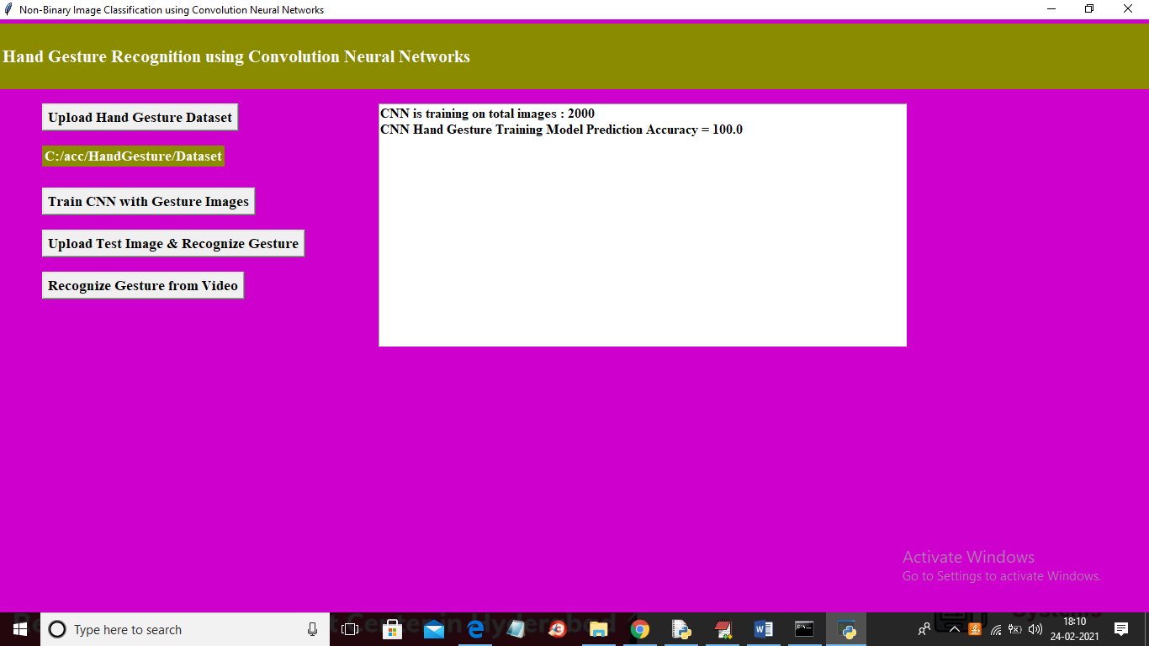
In above screen CNN model trained on 2000 images and its prediction accuracy we got as 100% and now model is ready and now click on ‘Upload Test Image & Recognize Gesture’ button to upload image and to gesture recognition
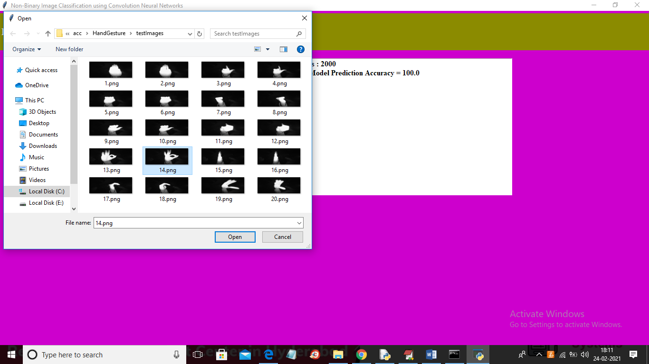
In above screen selecting and uploading ’14.png’ file and then click Open button to get below result
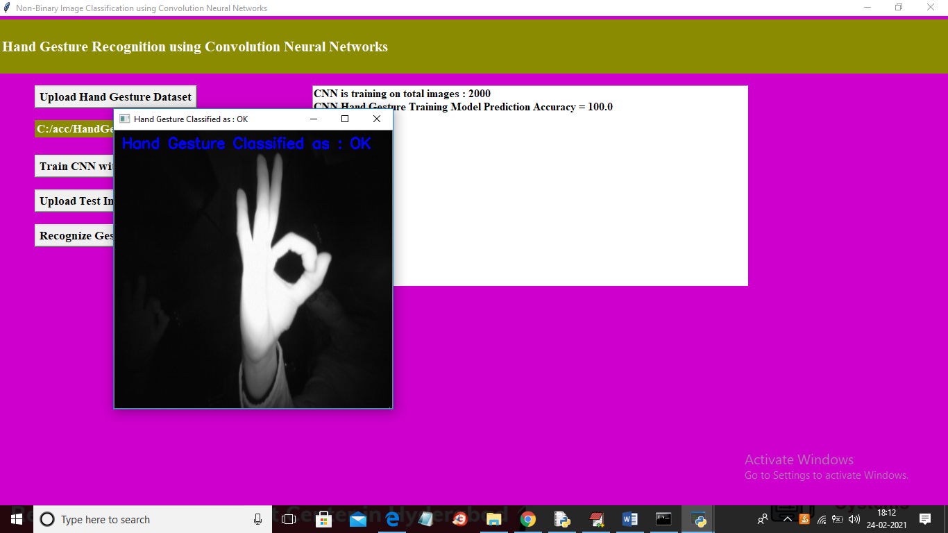
In above screen gesture recognize as OK and similarly you can upload any image and get result and now click on ‘Recognize Gesture from Video’ button to upload video and get result
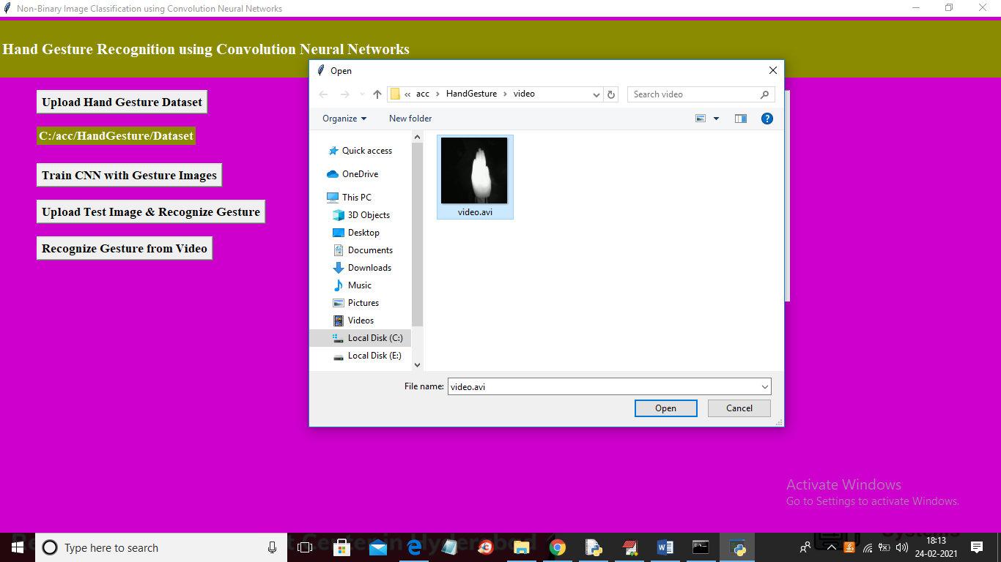
In above screen selecting and uploading ‘video.avi’ file and then click on ‘Open’ button to get below result
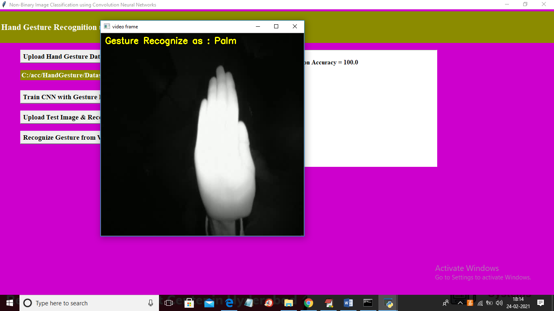
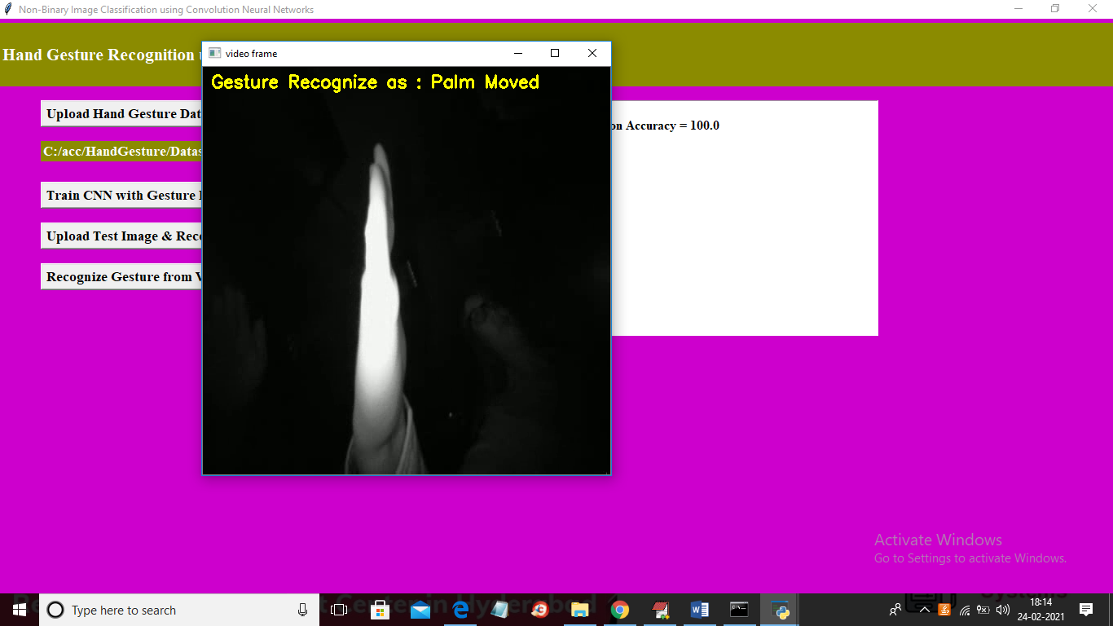
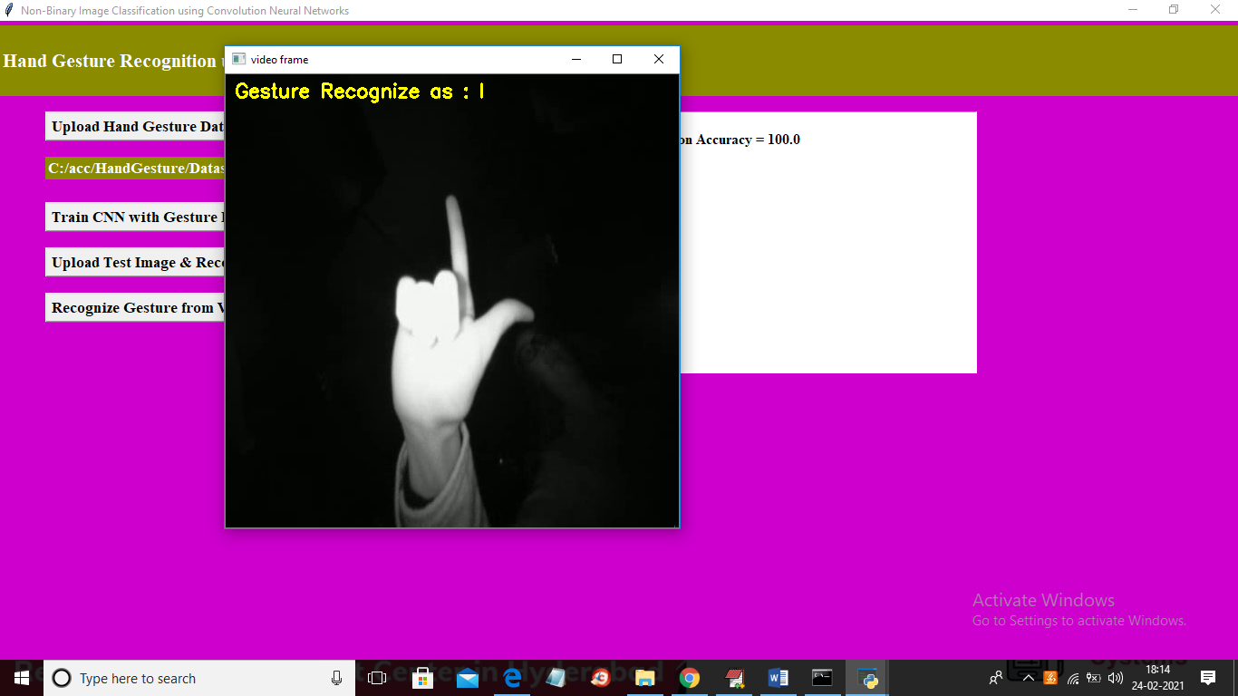
In above screen as video play then will get recognition result

